2026 Proposed Slate

Vestry Nominees (4 for three-year term)
- Martha Cox
- Shane Williams
- JJ Howell
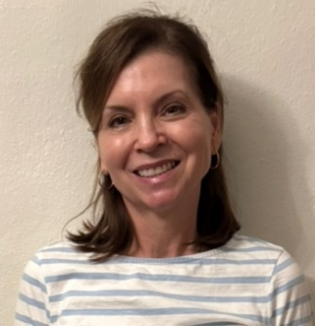
My husband, Chanley, and I moved to Jacksonville in 1988 and raised our two daughters, Maggie and Julia, here. We now cherish spending time with our new grandchild, George.

I was received into the Episcopal Church nearly 40 years ago. Several years ago, I was drawn to the Cathedral's inclusive community and its commitment to social justice. It was these core values that helped St. John’s become my church home. I feel incredibly blessed to be surrounded by such a warm and intelligent congregation, and the opportunity for deep spiritual and intellectual growth here has truly established my belonging.

I graduated from Vanderbilt University with a double major in English Literature and Fine Arts, and I later earned a Master’s degree from the University of Florida in Public Relations and Journalism. I retired from teaching a year and a half ago, though I still occasionally substitute. My true passion, however, is tutoring refugee children at Kim’s Open Door, a wonderful local non-profit. I run the Summer Language Institute for children aged 5 to 18 and tutor high school students twice a week during the school year.

My professional background has long revolved around community and service; my husband and I were proud owners of The Village Cafe in Ortega for several years. This experience instilled in me a deep appreciation for the art of hospitality and the importance of creating a welcoming space where everyone feels seen, valued, and nourished—principles I strive to bring to my life at the Cathedral.

At the Cathedral, I am an active member of the Arts Exhibition Committee and love participating in the "Soul Gardening" program. I recently had the honor of leading a presentation on Christian Mystics. I am grateful for the deep sense of community here and would be honored to serve on the vestry to help support the Cathedral's vibrant and welcoming mission.

- Rebecca Black (headshot needed)

After fifteen years in the international food and beverage industry, Rebecca Black transitioned into the light industrial temporary field, providing labor to packing and shipping warehouses. After five years, she decided to go to law school and earned her JD from Florida Coastal School of Law.

She had worked with many immigrants over the years and wanted to help people achieve legal status and the American Dream. She also has an MBA from Marymount University and earned her bachelor’s at UVA. After law school, she worked for David Fletcher, an immigration attorney with twenty-some years of experience, before going out on her own in January 2013. She has built a successful practice in Jacksonville, helping immigrants and businesses with their immigration needs.

Rebecca Black grew up in Fairfax, Virginia, and has also lived in Spain, France, and Atlanta, Georgia, before moving to Jacksonville, FL. She is married to Mike Munsch, and they have four cats.

Vestry Alternate Nominees (2 for one-year term)

- Marianne McAlhany-Murray (Headshot needed)
After graduating from Northwestern University with a degree in voice, I moved to New York City where I toured with The Goldovsky Opera Company and The Gregg Smith Singers. I was also a member of Musica Sacra at Lincoln Center, along with performing in many summer stock productions in New York.
I met my husband, Jim, in New York City, where we married in 1989. With our two children, Andrew and Claire, we moved to Belgium where we lived as ex-pats for three years while Jim worked for Citibank. Upon returning to the states, we settled in Ponte Vedra. We were blessed with discovering St. John’s, where I have been a member of The Cathedral Choir, an Acolyte, and a Verger. I have also taught the choir school and was part of the Cathedral Choir’s pilgrimages to Canterbury Cathedral and National Cathedral in D.C.
St. John’s Cathedral has truly embraced me with the loving arms of fellowship and support, especially during this past year during the loss of my sister Liz McAlhany, and the difficult decision to transition my husband to a memory care home as his dementia progresses. My hope is to be able to give back to this loving, inclusive congregation and clergy in whatever ways possible.
- Caroline Nichols

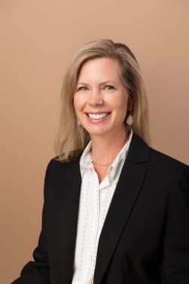
I was born and raised in Jacksonville and am a graduate of the College of William and Mary and the University of Georgia School of Law. As a real estate attorney, I have been practicing in the Jacksonville area for 23 years, working in real estate firms representing real estate developers, as in-house counsel, as a Professor of Property Law and Legal Writing with Florida Coastal School of Law, and I currently manage the Clay County office for Landmark Title. I have been married to Gene Nichols for 23 years, and we raised our children, Catherine (20) and Richard (20) in the Episcopal Church.

I am a life-long Episcopalian and was baptized, confirmed, and married at St. Mark’s Episcopal Church in Jacksonville. While at St. Mark’s, I served as a member of the Vestry, the Lay Director of Christian Formation, a facilitator of children’s and adults’ Christian Formation offerings, a Youth Confirmation facilitator, a member of the Strategic Planning Committee, and a lector, chalice bearer, and Lay Eucharistic Visitor. Approximately three years ago, Gene and I experienced worship at St. John’s Cathedral, and we were immediately struck by the warmth of its welcoming community and began to get involved. In 2025, I committed to weekly worship and engagement at the Cathedral and officially transferred my membership. At the Cathedral, I feel particularly drawn to engage with a downtown parish in the heart of Jacksonville that connects with people throughout the area and that pushes us to genuinely live God’s call to seek and serve all people as children of God. I am inspired by the Cathedral’s mission of giving to St. Mary’s, Church Without Walls, Hunger Fight, outreach to immigrants, dialogue with leaders from different faiths, advocacy for the Urban Core, and similar ministries that actively embrace all of God’s people. At the Cathedral, I attend worship and Dean’s Forum enthusiastically, am engaged with a Discipleship Group, have served as a Lenten Small Group facilitator, am currently serving on the planning committee for the upcoming Women’s Retreat, and am seeking opportunities to deepen my involvement with the Cathedral and its service to the community.

Diocesan Convention Nominees (4 – serve the remainder of their two-year term through 2026; next year, we will elect two nominees for a two-year term and two for a one-year term to get back to just electing two each year for alternating terms)

- Donna Walker Bell
- T.R. Hainline
- Brooks Moore
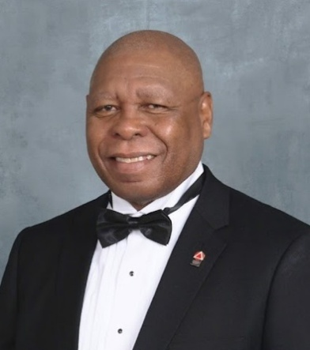
- Andrew Brown
My journey began at St Paul’s Episcopal Church, Atlantic Boulevard, Jacksonville. I had the privilege of attending my confirmation class at St John’s Cathedral and was confirmed May 28, 2023. On my first visit to the Cathedral I enjoyed the welcoming atmosphere, the liturgy and the music, so I decided to make St John’s Cathedral my home.

By being active in the church, I have been spiritually blessed, as I have had the honor of serving in various acolyte roles including that of Eucharistic Minister and Eucharistic Visitor. I was also installed as a Verger. I have completed the Alpha Study Course and the Safeguarding Church program. I am also a second-year participant in the Education For
Ministry program.

I come from a military background, and have extensive experience in Office Administration and Records Management. I have a Bachelor of Science Degree in Criminal Justice. I am a Notary Public and Signing Agent for the State of Florida.

I am honored to be selected as a delegate to represent the St John’s Cathedral. Wherever the Lord leads I will follow, and I pray for His continued blessing on my life and my spiritual growth. With God’s help, I will steadfastly continue to uphold my baptismal vows and offer my service to the Lord and my church community.

Diocesan Convention Alternates (2 for one-year term)
- Glenn Guiler
- Chris Collinsworth
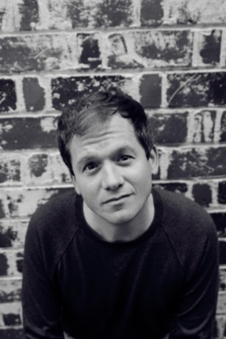
I am honored to be considered as an alternate delegate to the Diocesan Convention representing St. John’s Cathedral. I bring to this role a long-standing commitment to the life of the Church, informed by both leadership experience and active service.
I have previously served as a diocesan convention delegate, vestry member, verger, lector, and children’s ministry leader. These roles have given me a broad understanding of parish life, diocesan governance, and the importance of faithful representation and thoughtful discernment.

Professionally, I am an educator with Duval County Public Schools and serve as an adjunct professor at the University of North Florida. My work in education shapes my approach to listening, collaboration, and advocacy—skills that are essential in diocesan leadership and decision-making.

Beyond church and professional life, I value creativity and community engagement. I serve on the board of the Five & Dime Theatre, enjoy acting, and will be directing a play in the 2026 season. In my spare time, I treasure time with my family and reading.

If selected, I would bring experience, attentiveness, and a deep love for St. John’s Cathedral and the Diocese to the work of the convention. I am grateful for the opportunity to continue serving our church in this capacity.

